Notice:

Some contents in the project document differ from one another. If you have any questions or need clarification, please feel free to contact the Project Coordinator.
[Reactive SIEM]


By:

Sameer Hassan
46196
Muhammad Zain ul Abiddin
44709
Nasir Hussain
43913

Supervised by:
[Mr Hummayun Raza]

Faculty of Computing
Riphah International University, Islamabad
Spring/Fall 2025
Submitted To

Faculty of Computing,
Riphah International University, Islamabad
As a Partial Fulfillment of the Requirement for the Award of the Degree of
Bachelors of Science in Cyber Security

Faculty of Computing
Riphah International University, Islamabad

Final Approval

This is to certify that we have read the report submitted by Sameer Hassan 46196, Muhammad Zain ul Abiddin 44709 and Nasir Hussain 43913 for the partial fulfillment of the requirements for the degree of the Bachelor of Science in Cyber Security (BS CYS). It is our judgment that this report is of sufficient standard to warrant its acceptance by Riphah International University, Islamabad for the degree of Bachelor of Science in Cyber Security (BS CYS).

Committee:

1 | [Mr Hummayun Raza]  (Supervisor)
2 | [Dr. Musharraf Ahmed]  (Head of Department/chairman)

Declaration

We hereby declare that this document “[Reactive SIEM]” neither as a whole nor as a part has been copied out from any source. It is further declared that we have done this project with the accompanied report entirely on the basis of our personal efforts, under the proficient guidance of our teachers especially our supervisor [Mr Hummayun Raza]. If any part of the system is proved to be copied out from any source or found to be reproduction of any project from anywhere else, we shall stand by the consequences.

___________________________
[Sameer Hassan]
[46196]

___________________________
[Muhammad Zain ul Abiddin]
[44709]

___________________________
[Nasir Hussain]
[43913]

Dedication

We dedicate this work to our families, whose unwavering love, support, and encouragement have been our cornerstone; to our parents, for their wisdom, tolerance, and faith in our abilities; to our friends, for their understanding and unceasing inspiration; and to our mentors, who motivated us with their expertise, wisdom, and commitment.
Additionally, this book is dedicated to everyone who shares the pursuit of excellence, knowledge, and an innovative spirit. Together, we hope to make a significant impact and help create a safer and better world.

Acknowledgement

First of all, we are obliged to Allah Almighty the Merciful, the Beneficent and the source of all Knowledge, for granting us the courage and knowledge to complete this Project.
We would like to sincerely thank everyone who helped us with this project and the "Reactive SIEM" report that went with it. First and foremost, we would like to express our sincere gratitude to our teachers, particularly Mr. Hummayun Raza, our supervisor, for his unwavering support, encouragement, and technical assistance. Their insightful opinions and helpful criticism were crucial in helping to shape this project into what it is today. We also thank our classmates for their encouragement, teamwork, and constructive rivalry throughout this project. Our educational experience was substantially improved by their support and openness to sharing ideas.

___________________________
[Sameer Hassan]
[46196]

___________________________
[Muhammad Zain ul Abiddin]
[44709]

___________________________
[Nasir Hussain]
[43913]

Abstract

By enabling real-time monitoring and prompt responses to security threats, the Reactive SIEM project seeks to improve cybersecurity. It collects and decodes security logs from Windows and Linux operating systems, emphasizing significant access and authentication-related events. Admin logins (Event ID 4672)[4], account lockouts (Event ID 4740)[5], group membership changes (Event IDs 4728–4733)[], account management actions (Event IDs 4720[6], 4726)[7], password changes (Event IDs 4723[8], 4724)[9], failed and successful logins (Event IDs 4625, 4624)[10], and system startup/shutdown, driver loading, and service events are examples of key events. These logs are crucial for identifying security flaws and ensuring that threats are promptly addressed. This system is unique in that it automatically evaluates incoming data and modifies its rules in response to emerging threats. IP lookup, IP reputation checks, geolocation tracking, and the ability to manage dynamic blocklists and whitelists are a few of the primary features. Together, these tools reduce false alarms by ensuring that only the most dangerous threats are detected. Logs are currently saved by the system in JSON format. As the system expands, it will transition to a better database solution in the subsequent phase. This project's main goal is to automate the process so that security teams can more easily identify and address threats. Two agents—one for Linux and one for Windows—are used by the Reactive SIEM system to ensure that crucial logs from both operating systems are gathered, decoded, and displayed on an intuitive dashboard. This makes it simpler for security professionals to monitor threats, identify them, and address them as they arise.

Table of Contents

List of Figures | 1
List of Tables | 2
Chapter 1: Introduction | 3
- Opportunity & Stakeholders | 4
- Motivations and Challenges  - Significance of study | 5  5
- Goals and Objectives | 6
- Scope of project  - Chapter Summary | 6  6
Chapter 2: Literature / Market Survey 7
2.1 Introduction 7
2.2 Literature Review/Technologies & Products Overview 8
2.3 Comparative Analysis 12
2.4 Research Gaps 13
2.5 Problem Statement 14
2.6 Chapter Summary 14

Chapter 3: Requirements and System Design 15
3.1 Introduction 15
3.2 System Architecture 16
3.3 Functional Requirements 17
3.4 Non-Functional Requirements 18
3.5 Design Diagrams (such as use cases, dataflow diagrams, sequence diagram etc. not limited to) 19
3.6 Hardware and Software Requirements 19
3.7 Threat Scenarios (Threat Handling [Here can be models / techniques /new approaches]) 21
3.8 Threat Modeling Techniques 2 2
3.9 Threat Resistance Model 23
3.10 Chapter Summary 24
Chapter 4: Proposed Solution 25
4.1 Introduction 25
4.2 Proposed Model (Explanation of approach whether quantitative, qualitative and experimental.) 26
4.3 Data Collection: (How data will be gathered for the project such as network logs, survey responses). 27
4.4 Data Pre-Processing (outlier removal, filtering, classification, clustering, prioritization) 27
4.5 Tools and Techniques (Specific method i.e. penetration testing, encryption, machine learning models etc. used in projects). 28
4.6 Evaluation Matrices (Criteria for assessing the project, accuracy, speed or security robustness.) 29
4.6 Chapter Summary 30

Chapter 5: Implementation and Testing 31
5.1Security Properties testing 31
5.2 System Setup (Environment Configuration, Key functions and Algorithms) 32
5.3 System integration (Components integration, Communication protocols/s APIs, Databases or log management setup). 33
5.3 Penetration Testing and Vulnerability Assessment (*optional) 33
5.4 Reverse Engineering and Malware Analysis (*optional) 34
5.5 Test cases 35
5.6 Results and discussion 36
5.7 Best Practices / Coding Standards 37
5.5.1 Code Validation
5.5.2 Development Practices & Standards
5.8 Chapter Summary 38
Chapter 6: Conclusion and Future Work 39
6.1 Introduction 39
6.2 Achievements and Improvements 40
6.3 Critical Review 41
6.4 Future Recommendations 42
6.5 Chapter Summary 43
References (list of all sources references throughout the report, formatted according to appropriate citation style i.e IEEE) 44
Appendices 45

List of Figures

1.1 System Architecture Overview | 4
1.2 Reactive SIEM Event Flow | 5
2.1 Traditional SIEM System vs Reactive SIEM | 7
2.2 Comparative Analysis of SIEM Solutions | 8
2.3 Reactive SIEM System Architecture | 12
5.1 SIEM System Testing and Evaluation | 31
5.2 Penetration Testing Process Flow | 32
6.1 Overview of Siem Dashboard Displaying Alerts, Logs, Agent Status | 39
6.2 Log Viewer Display with Warning Level | 40
6.3 Ip Intelligence Dashboard Display | 41
6.3 Tracked Ip address Information Display | 42
12 Performance Metrics Chart | 62
13 Security Events Logs Display | 63
14 Reactive SIEM System Architecture | 64
15 Threat Resistance Model | 67

List of Tables

1.1 System Requirements for Reactive SIEM | 4
1.2 Functional and Non-Functional Requirements | 5
2.1 Comparison of Traditional and Reactive SIEM Systems | 7
2.2 Research Gaps in SIEM Solutions | 8
2.3 Feature Comparison of SIEM Systems | 12
5.1 Testing Results for Reactive SIEM System | 31
5.2 Penetration Testing and Vulnerability Assessment Results | 32

Chapter 1:
Introduction

Chapter 1
Introduction

  - Opportunity & Stakeholders
Cyberattacks are becoming more frequent and sophisticated as the world grows more digital, which is a major issue for companies across all industries. These attacks, which frequently alter in real time, exploit security system flaws, making it more difficult to protect sensitive data and maintain operations. As a result, businesses and organizations are investing heavily in cybersecurity solutions to safeguard their data and maintain the functionality of their networks. Security Information and Event Management (SIEM) systems, which provide real-time analysis of security incidents, are among the most crucial tools for monitoring and safeguarding networks.
To identify known threats, however, conventional SIEM systems use static rule sets. These systems are effective at spotting known, well-researched attacks, but they frequently have trouble spotting more recent, intricate attack techniques that are always changing. The Reactive SIEM system is useful in this situation. This project provides a solution that adjusts to new threats, enhancing the security posture of enterprises by enabling real-time event monitoring and dynamic threat mitigation.

The following are the main players in this project:

- Cybersecurity analysts: To identify possible risks and lessen their manual labor, these experts require real-time insights into security events. The goal of this project is to help analysts concentrate on critical incidents by automating the detection and response process.
- Businesses: To safeguard confidential information and guarantee continuous operations, businesses need strong network security. By providing proactive threat mitigation and real-time monitoring, the Reactive SIEM system assists companies in protecting their IT infrastructure.
- Compliance officers: They are in charge of making sure businesses adhere to rules and standards regarding security. By offering automated tools for monitoring and reacting to possible security breaches, the Reactive SIEM system helps compliance officers maintain the organization's compliance with security standards.
1.2 Motivators and Difficulties
The primary objective of this project is to address the shortcomings of traditional, rule-based SIEM systems. These systems are effective at identifying known threats, but they struggle to identify more modern or sophisticated attack techniques. Additionally, these systems rely on static rules, which need to be updated regularly to stay operational. To keep the system up to date, this approach requires a lot of time, effort, and resources.
This project attempts to solve these problems by developing a reactive system that can quickly adapt to new threats. By analyzing critical event logs from Windows and Linux systems, the technology can detect and remove threats as they emerge. The system proactively resolves issues before they have a chance to get worse by using state-of-the-art techniques like geolocation monitoring and IP reputation research. One of the biggest challenges for this project is handling the enormous volumes of logs generated by modern networks. The system's capacity to manage this data efficiently, integrate with existing security technologies, and expand is essential to the project's success.

1.3 Significance of study
The potential for this work to alter the operation of SIEM systems makes it significant. Traditional SIEM solutions are not very good at addressing new and unknown threats, even though they perform well for known attack patterns. By adopting a reactive, real-time methodology, this project aims to create a dynamic, adaptive system that continuously learns from novel data patterns. The Reactive SIEM system goes beyond static rules by analyzing event logs from both Linux and Windows systems and making use of features like IP threat management, geolocation monitoring, and dynamic blocklist/whitelist management.
This proactive approach improves response accuracy, expedites threat detection, and makes it easier for cybersecurity professionals to monitor, respond to, and mitigate attacks. The automation of the system reduces the need for manual interventions and enhances overall security management, allowing security personnel to focus on higher-priority tasks.

1.4 Objectives and Goals
The objectives of the Reactive SIEM project are to:
- Establish a Reactive SIEM Framework: The system will collect, analyze, and process event logs from Linux and Windows systems in order to detect and mitigate security threats in real time.
- Implement Advanced Security Features: Incorporate features like geolocation monitoring, IP reputation analysis, and dynamic blocklist/whitelist management to enhance the system's ability to respond proactively to threats.
Boost Scalability: In order to efficiently handle growing data volumes, the system will transition from JSON-based log storage to a more scalable, database-driven method as it grows.
- Real-Time Alerts and Automation: Security teams will be able to respond to threats faster and with less manual intervention if threat detection, classification, and mitigation are automated.

1.5 Project Scope
The primary objective of this project is to analyze significant security event logs generated by Linux and Windows systems. The primary focus is on high-priority event logs related to authentication and access control (such as Event IDs 4624, 4625, 4672, and others). These logs are crucial for identifying any security threats, such as unauthorized access or failed login attempts.
In the initial stage, logs will be kept in JSON-based storage. As the system expands, a more dependable, database-driven solution will be used to manage larger datasets and improve data management.
The system will have features like real-time IP threat analysis, geolocation monitoring, and dynamic blocklist/whitelist management in addition to monitoring these records. This approach minimizes unnecessary warnings and allows cybersecurity teams to respond faster by guaranteeing that only relevant threats are reported.

1.6 Chapter Summary
This chapter introduced the Reactive SIEM project, highlighting its importance in tackling the escalating challenges of modern cybersecurity. It explained why standard SIEM systems are not always effective in dealing with new and complicated threats and how the Reactive SIEM system provides a flexible and dynamic solution. With a focus on quick threat detection and real-time analysis, this system aims to give businesses a more flexible and responsive way to improve security in a changing environment. The chapter also discussed the key participants in the project, including cybersecurity analysts, companies, and compliance officers. These stakeholders will benefit from the system's ability to automate threat detection and response, which reduces the workload for security personnel. This chapter also discussed the project's goals, which included incorporating state-of-the-art features like IP reputation analysis, geolocation tracking, and dynamic blocklist/whitelist administration to improve security and speed up monitoring tasks. The project's scope, which includes obtaining and reviewing critical security logs from Windows and Linux servers, was also covered in this chapter. At first, logs will be kept in JSON format, but a database-driven solution will be used when the system grows and requires more scalability.

Chapter 2:

Literature / Market Survey

Chapter 2: Literature / Market Survey
2.1 Introduction

This chapter will look at recent research and technology developments related to SIEM (Security Information and Event Management) systems. These systems are widely used in cybersecurity to monitor and manage security events across an organization's network. We'll look at both the more well-known rule-based systems and the more versatile and flexible reactive SIEM solutions. As cybersecurity threats become more complex, organizations need systems that can not only manage current attacks but also respond to new, unidentified risks. This chapter will review the products and technologies currently available on the market, with a focus on those that allow automated mitigation and real-time threat detection. By understanding the challenges faced by traditional SIEM systems, we can better appreciate the advantages of more dynamic and adaptable solutions, like the one proposed in this study.
2.2 Literature Review/Technologies & Products Overview
    - The conventional SIEM systems:
Traditional SIEM systems primarily rely on pre-established rules to identify known attack patterns. Risks like brute force attacks and attempts to log in using credentials that have already been recognized and cataloged are successfully detected by these systems. For example, a SIEM system may flag a login attempt from an unknown IP address in line with a pre-established rule after a predefined number of unsuccessful login attempts.
However, there are some clear disadvantages to these traditional systems. Because they rely so heavily on current knowledge, they are only able to recognize threats that have already been detailed in their regulations. As cyberattacks continue to evolve, these algorithms may struggle to detect new, complex attacks that don't fit into their pre-established categories. Additionally, maintaining the relevance of the rules of older systems, which often require frequent human modifications, can be time-consuming and resource-intensive.

    - Systems for Reactive SIEM:
Emerging reactive SIEM systems have been developed to address the limitations of traditional rule-based techniques. Because they are not limited by predetermined rules, these systems are more dynamic; instead, they continuously analyze data patterns and adapt to new threats. Without requiring an update, reactive SIEM systems can identify and respond to threats in real time.
Instead of using a single rule, a reactive SIEM might, for instance, compare event logs from multiple systems with network traffic patterns. If it detects an anomaly—such as an abnormally high volume of access requests in a brief period of time—it can flag it as suspicious even in the absence of a set rule. These systems can detect previously unknown threats by identifying strange patterns, which improves their flexibility and quickness in reacting to novel attacks.
Reactive SIEM systems frequently include geolocation tracking, IP reputation analysis, and dynamic blocklisting/whitelisting. These features, such as whether an IP address has previously been linked to malicious activity or whether a login attempt is coming from an unexpected geographic region, help identify threats based on external intelligence.

    - Comparative Analysis
Conventional SIEM systems and reactive SIEM solutions are very different:

- Traditional SIEM systems identify threats using pre-established patterns and rules. They are excellent at identifying known attacks that meet those requirements. However, they might have trouble handling new or unseen risks. Because their regulations must be updated frequently, they are always required to stay up to date with new threats.
- Reactive SIEM systems are designed to be dynamic and rely on human-based analysis rather than static rules. They continuously monitor and analyze the data they collect in real time. Because these systems don't rely on predefined attack patterns, they can identify anomalies or suspicious activity even if they don't match known threats. If suspicious IPs are discovered, the system also performs a black-box analysis, which investigates the IP's origin, examines tactics, methods, and procedures (TTPs), and looks for any additional relevant information to assess any risks. Because of this approach, reactive SIEM systems are particularly well-suited for modern cybersecurity scenarios, where new and evolving threats are frequent.
Since reactive SIEM solutions can analyze network traffic, event logs, and external threat intelligence sources like IP reputation and geolocation data, they have a significant advantage over traditional techniques. They are not bound by preset rules and can respond to threats as they arise.

2.4 Research Gaps
Although reactive SIEM systems are superior to traditional systems in many ways, there are still some problems that need to be fixed:
- Real-Time Log Processing: One of the primary problems with reactive SIEM systems is processing enormous volumes of logs in real time. It becomes more challenging to quickly and accurately analyze everything as more systems and devices provide data. The system must be efficient enough to manage massive amounts of data without causing delays that could allow an attack to succeed.
- Reducing False Positives: Reactive systems may occasionally flag normal behavior as suspicious, even though their purpose is to identify unusual patterns. This is known as a false positive. Finding the perfect balance between being sensitive enough to detect real threats and specific enough to avoid unnecessary alarms is one of these systems' biggest challenges.
- Easy Integration with External Data Sources: Including external data sources, like IP reputation databases and geolocation information, in a reactive SIEM system can be difficult. For example, IP reputation databases need to be updated often to stay up to date, and it may be challenging to ensure that the system can adapt to those changes. Additionally, seamless integration with other security technologies (like firewalls, IDS/IPS, and antivirus software) is necessary for a cohesive security environment.

2.5 Problem Statement
Traditional SIEM systems are ill-suited to handle the new and evolving types of cyberthreats, especially in real-time settings. These systems are vulnerable to becoming outdated or ineffective against new attack vectors because they are based on static rules. This project aims to overcome these limitations by developing a reactive SIEM system that uses real-time event log analysis, IP reputation analysis, geolocation monitoring, and dynamic blocklist/whitelist management to proactively detect and mitigate risks.
By incorporating these reactive behaviors, the system will be able to react to emerging threats more rapidly and precisely. This approach will provide a more flexible, scalable, and adaptive solution while reducing the workload for cybersecurity experts.

2.6 Chapter Summary
This chapter provided a thorough analysis of current SIEM systems, contrasting more established rule-based systems with more recent reactive SIEM solutions. Conventional SIEM systems are good at identifying well-known attack patterns based on predefined rules, but they have significant limitations when it comes to identifying new, undiscovered threats. Due to their dependence on static rules, they often require frequent updates to remain current and struggle to adapt to novel attack types.
Conversely, reactive SIEM systems offer a more adaptable and dynamic approach. Because they continuously analyze data and learn from real-time events, they are better able to recognize new risks and respond to them. By analyzing network traffic, event logs, and external intelligence sources like IP reputation and geolocation monitoring, reactive systems are better suited to modern cybersecurity scenarios where new threats abound. However, as the chapter highlights, reactive SIEM systems continue to face challenges. These challenges include reducing false positives, swiftly processing large volumes of logs, and ensuring seamless integration with external data sources. These challenges present opportunities for innovation and progress in the cybersecurity sector.
The problem statement for the project made clear how insufficient standard SIEM systems are to handle the new and rapidly evolving types of cyberthreats. The Reactive SIEM system aims to get around these limitations by using state-of-the-art techniques like dynamic blocklist/whitelist management, IP reputation analysis, geolocation monitoring, and real-time event log analysis to proactively identify and eliminate threats. By doing this, the system offers a more flexible, scalable, and adaptive approach to addressing the growing complexity of modern cyberthreats.

Chapter 3:
Requirements and System Design

Chapter 3: Requirements and System Design

3.1 Introduction
This chapter describes the needs and design of the Reactive SIEM system as well as the functional and non-functional requirements that must be met for the system to operate correctly. We'll look at the specific features that the system needs to have as well as how well they work. We'll also talk about the system architecture as a whole and how its various components work together to monitor, assess, and respond quickly to potential security threats.
This chapter also provides an overview of the design diagrams, which show how the various components of the system interact graphically. The hardware and software requirements are also explained to ensure the system will work properly, and various threat scenarios are displayed to show how the system should handle specific types of security threats.

3.2 System Architecture
The Reactive SIEM system's ability to recognize, evaluate, and respond to security threats depends on its two main architectural components:
- Agents for Event Collection: These are small programs that are set up on networked Windows and Linux computers. Their primary responsibility is to collect security logs from the systems. These logs contain information about significant events, such as login attempts and changes to access control. The agents focus on ten critical event IDs, including 4624, 4625, and 4672, to monitor authentication events and unauthorized access. The logs are collected and then sent to the central server for processing and further analysis.
- Centralized Server: The central server is responsible for aggregating the logs collected by the agents. It performs essential analysis tasks like:
- IP Reputation Checks: The server examines the IP addresses involved in the events to see if they are associated with malicious activity.
- Geo-Location Tracking: The server looks at the login attempts' geographic location to determine whether they come from unexpected or suspicious sources.
- Dynamic Blocklist/Whitelist Management: The server can automatically update a blocklist or whitelist based on the analysis to control which IP addresses are allowed or prohibited access to the system.

- The server processes these logs in real-time and presents the results on an easy-to-use dashboard. This enables administrators to quickly assess the situation, monitor security events, and take immediate action by blocking suspicious IP addresses or investigating potential threats.
This design ensures that the system can expand with the network while still responding swiftly to potential threats. The system's ability to adapt to new security events makes it a powerful defense against ever-evolving cyberthreats.

  - Functional Requirements
The Reactive SIEM system must meet several essential functional requirements in order to operate effectively. These specific tasks must be completed by the system:
- Log Collection: The system should be able to gather Windows and Linux logs in real time. The primary focus of the logs should be on high-priority event IDs (like 4624, 4625, and 4672) that are crucial for tracking security events, like authentication failures and unauthorized access attempts.
- Threat Detection: The system needs to review the collected logs in order to spot potential threats. The primary features of threat detection are as follows:
- IP Reputation Checks: Based on the logs, the system looks at the reputations of the IP addresses. If the system detects an IP address as malicious (for instance, originating from a known blacklisted source), it will either automatically block the IP address or flag the event for further investigation.
- Geo-area tracking: By analyzing the geographic location of login attempts, the system can ascertain whether a login is coming from an unexpected or suspicious area, such as a country the user does not typically access from.
- Dynamic Blocklist/Whitelist Management: Based on log analysis, the system will automatically update the blocklist/whitelist of IP addresses to keep malicious actors out of the network.
- Real-Time Logs: The system must continuously collect and process logs in real-time. As soon as a threat is detected, the logs are updated with detailed information (such as event ID, related IP addresses, and threat category). These real-time logs, once displayed on a dashboard, allow managers to monitor security events and respond quickly. This can mean blocking a suspicious IP address or quickly adjusting security settings.

  - Non-Functional Requirements
To guarantee that the Reactive SIEM system operates efficiently in a real-time setting, it must also fulfil a number of non-functional requirements in addition to the functional ones:
- Scalability:
The system needs to be scalable without sacrificing performance as the network expands. The system must to be capable of effectively managing an increasing quantity of logs and agents. In order to handle higher data volumes, it should be able to accommodate the installation of additional systems and dispersed servers.
- Real-Time Processing:
To guarantee prompt alerts and prompt answers, the system must process logs reliably and swiftly. It should manage massive volumes of data without creating delays that can enable security risks to thrive.
- Security:
All data must be delivered and stored securely because the system handles sensitive data, including event data and authentication logs. This entails protecting logs from manipulation and unauthorized access, as well as encrypting data in transit (using TLS).

3.5 Design Diagrams (such as use cases, dataflow diagrams, sequence diagram etc. not limited to)
There are a number of design diagrams that show how data flows through the system and how its parts work together:
- Data Flow Diagrams (DFD):
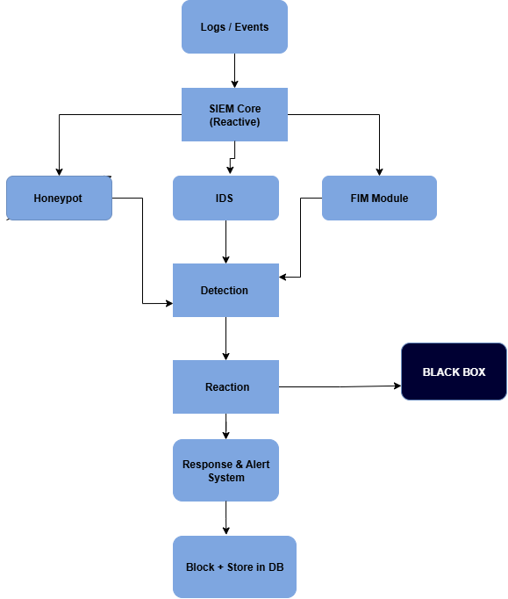
Fig 1: (Reactive SIEM Flow: Logs -> Detection -> Reaction -> Black Box -> Alerts and Blocking)
- System Architecture Diagram:[1]
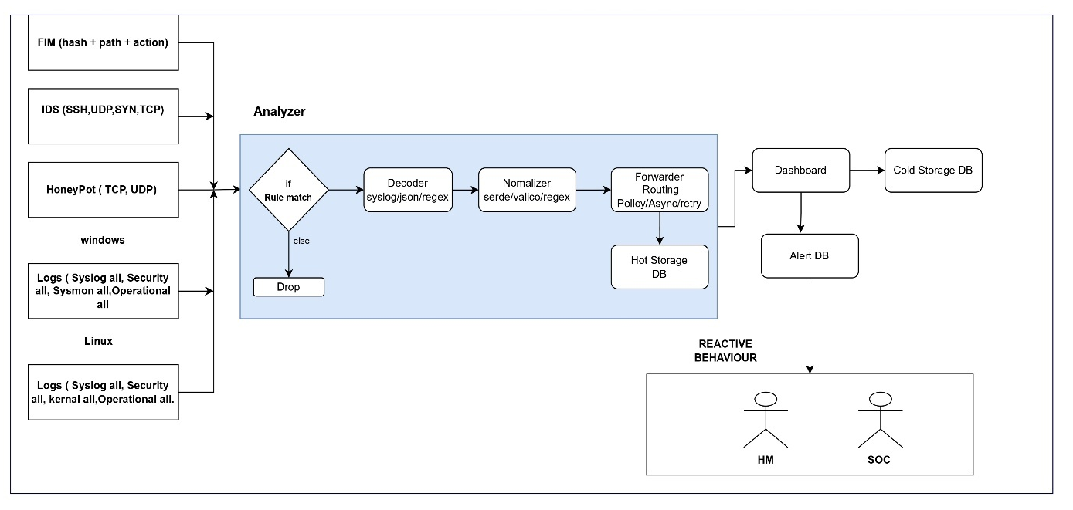
Fig 2: (Reactive SIEM Analyzer Workflow)
3.6 Hardware and Software Requirements
Certain hardware and software requirements are necessary for the Reactive SIEM system to operate correctly:

3.6.1 Hardware:
- Multi-Core Processor: To analyses massive amounts of log data in real time, the system needs a multi-core processor (such as an Intel i5/i7 or its equivalent).
- 8 GB RAM: The system requires enough memory to manage many jobs at once, process event logs, and provide delay-free real-time threat detection.
- 256 GB SSD: To process massive datasets efficiently, the system needs fast storage to guarantee quick access to logs and system data.

3.6.2 Software:

- Syncing and Concurrency:
- Parking Lot v0.12: Implementations of Mutex
- Futures version 0.3: Async tools

- System Tools:
- Chrono v0.4: Managing dates and times
- Web browser v0.8: Programmatically launch the browser

- Optimization:
- Enabled LTO (Link Time Optimization)
- Level 3 Optimization: Optimization for Release

- Testing and Development:
- PowerShell v5.1: Automation of builds and tests
- The test suite runner is run-tests.ps1.

- Information and Logging:
- JSON: Data format (ips. Json, alerts. Json)
- XML: Log format (logs.xml)
- Rolling Log Files: File-based logging

- System Surveillance:
- Event ID tracking (4624, 4625, etc.) in Windows Event Viewer
- Event tracking and registry and process monitoring

- Project Organization:

- Workspace with three modules: Windows Agent, Linux Agent, and Server
- Support for both Linux and Windows

- Data serialization:

- Serialization/deserialization (Serde v1)
- Safety:
- TLS encryption, or rustls-tls
- UUID v1: Generation of unique identifiers

- Tracing and Logging:
- Structured logging in Tracing v0.1

- Essential Technologies:
- Programming language: Rust; package manager: Cargo; async web framework: Axum v0.7; async runtime: Tokyo v1

3.7 Threat Scenarios
The Reactive SIEM system is intended to identify and address a range of security risks, such as:

- Unauthorized Access Attempts: The system keeps an eye out for unauthorized access attempts and frequent login failures, as they could point to a possible attack or compromised account. These occurrences are flagged for more research or automated action.
- Brute Force Attacks: Several unsuccessful attempts to log in from the same IP address are detected by the system. The system may block the IP address to stop more unsuccessful login attempts if the number of attempts surpasses a certain threshold.
- Anomalies: To find unusual activity that deviates from the expected behavior, the system employs anomaly detection techniques. In order to detect possible threats that might not adhere to a known attack pattern, this could involve things like login attempts made at odd hours or access to resources that are forbidden.

3.8 Threat Modeling Techniques

STRIDE
- Spoofing: UUID spoofing and phony agent identities
- Tampering: Modification of event data during storage or transit
- Repudiation: Agents refute sending malicious events through repudiation.
- Information Disclosure: Unauthorized access to IPs and logs
- Denial of Service: Overloaded server, depleted resources
- Elevation of Privilege: The agent obtains administrator rights to circumvent restrictions

DREAD
- Potential Damage: Serious data breach versus small-scale log loss
- Reproducibility: Easily exploitable versus requiring certain circumstances
- Exploitability: Simple attacks versus those requiring in-depth knowledge
- Affected Users: Every user as opposed to just one agent component
- Discoverability: Visible weakness as opposed to obscure or difficult to detect
3.9 Threat Resistance Model
To make sure it can withstand different kinds of cyberthreats, the system employs a multi-layer defense strategy:
- Resistance to authentication
- Current Defense: cookie-based sessions and UUID-based agent identification
- Level of Resistance: Medium (needs improvement)
- How to Strengthen: Use certificate pinning, add MFA for dashboard access, add token rotation, and implement OAuth2.

- RESISTANCE TO ENCRYPTION
- Rustls-TLS for network traffic is the current defense.
- Level of Resistance: Strong (for transit)
- How to Strengthen: Use TLS 1.3+ at the very least, implement HMAC signature on all events, and add AES-256 encryption for JSON/XML files at rest.

- RESISTANCE TO INJECTION ATTACKS
- Present Defense: Regex input validation
- Level of Resistance: Medium (basic protection)
- How to Strengthen: Use prepared statements, apply Content Security Policy (CSP), sanitize all user input, and add parameterized queries.

RESISTANCE RATING
Threat Type | Current | Target | Gap
Authentication | 5/10 | 9/10 | 4
Encryption | 8/10 | 10/10 | 2
Injection | 5/10 | 9/10 | 4
DoS | 3/10 | 8/10 | 5
Data Integrity | 5/10 | 10/10 | 5

  - Chapter Summary
An extensive overview of the Reactive SIEM project's system design was given in this chapter. It described the system's general design, dividing its essential elements into the central server and the event gathering agents. The chapter explained how these elements work together to gather, handle, and examine security event logs from Windows and Linux systems. We also talked about the functional requirements that the system needs to fulfill in order to be able to identify, evaluate, and react to possible threats instantly. These contain important functions including IP reputation analysis, geolocation monitoring, real-time log gathering, and dynamic blocklist/whitelist administration. In order to guarantee that the system functions smoothly and safely as the network expands and changes, non-functional needs including scalability, real-time processing, and security were also discussed. The architecture of the system enables it to scale and adapt efficiently while still reacting swiftly to security events. Together, the agents' role in real-time data collecting and the central server's capacity to aggregate and analyze logs result in a complete security solution that reacts to threats as they materialize. Administrators can act quickly since the dashboard interface gives them an easy-to-understand snapshot of ongoing security incidents. This chapter covered the architecture as well as the hardware and software needed to make sure the system functions properly. A multi-core processor, 8 GB of RAM, and a 256 GB SSD are among the technical specs that provide the system the capacity it needs to manage massive data quantities. Real-time processing, event analysis, and integration with current security tools are supported by the software requirements, which include Python, Flask, Wazuh, and Rust. The threat scenarios that the system is intended to identify and counter were also covered in this chapter. These include anomalies in network activity, brute-force attacks, and unapproved access attempts. By utilizing multi-layered defense techniques, the threat resistance model guarantees that the system is safe from a range of possible attack vectors. Real-time dynamic IP blocking, threat classification, and anomaly detection are all included in the model to make sure the system reacts to attacks effectively and proactively.
In conclusion, this chapter provided a solid framework for comprehending how the Reactive SIEM system is built to satisfy contemporary cybersecurity requirements. To guarantee that the system can adjust to changing threats while preserving performance and security, the architecture, functional requirements, and threat detection capabilities were meticulously described.

Chapter 4:
Proposed Solution

Chapter 4: Proposed Solution
4.1 Introduction

Real-time event logs are monitored by the Reactive SIEM system, which also analyzes any security threats and, as soon as they are identified, automatically takes action to neutralize them. The system provides an effective way to shield businesses from online attacks by fusing event log monitoring with automatic mitigation and dynamic threat analysis. The capacity of the Reactive SIEM system to examine logs from Windows and Linux systems in real-time is essential to its efficacy. This enables the system to respond swiftly to risks like suspicious IP activity, brute-force login attempts, and unauthorized access. Event logs are continuously gathered by the system, which then examines them for indications of anomalous activity. It automatically blocks malicious IP addresses when a danger is identified and notifies administrators in real time so they may take appropriate action. The system can identify and react to new, unidentified dangers as they appear since it is taking a reactive approach. This guarantees that the security team won't need to update preset rules or do continuous human intervention. The solution makes the entire cybersecurity process considerably more efficient by automating threat detection, classification, and response. The technology is also built to increase the accuracy of real-time threat detection and reduce false positives, or improperly labeled legitimate behavior.

4.2 Proposed Model

Two essential elements are used by the Reactive SIEM system to identify, evaluate, and address security threats:
- Event Log Analysis: The process of analyzing event logs is the initial part of the system. Logs pertaining to important events like privilege escalation, access control, and authentication attempts are gathered by the system. For instance, a brute-force attack may be indicated if a single IP address is used in several unsuccessful login attempts. After that, the system examines these logs to look for any unusual activities. The system flags an incident for evaluation or action if the event logs show something out of the ordinary. Predefined patterns, such as repeated unsuccessful login attempts, attempts to access resources that are prohibited, and other behavior that deviates from the norm, are used in the study. The system looks for any variations that would indicate malicious activity by comparing these logs to established attack patterns.
- Reactive Behavior: By dynamically analyzing event data, the Reactive SIEM system responds to new risks, in contrast to traditional SIEM systems that solely rely on static rules. It uses more than just pre-established rules to identify dangers. Rather, it continuously looks for possible malicious activity by analyzing IP reputation, geolocation information, and login habits. For example, the system automatically blocks a suspect IP address and updates it blocklist. As a result, the system can respond swiftly to threats and does not require human involvement for each new security incident. Compared to rule-based systems, this dynamic behavior guarantees that the system can react to new threats as they appear, giving it far greater flexibility.

4.3 Data Collection

Logs from Windows and Linux systems can be gathered using the Reactive SIEM system. Gathering high-priority event logs pertaining to access control and authentication is the main goal. For instance, real-time tracking is done for important event IDs such as 4624 (successful login), 4625 (failed login), and 4672 (special rights provided). These logs include important information about who is using the system, when they are using it, and whether any unauthorized access is taking place.
As soon as these logs are gathered, the system examines them, enabling it to quickly detect questionable activities. The system makes sure it is not overloaded with data by monitoring only the most important event logs, allowing it to concentrate on what really matters—real-time threat detection. The system increases efficiency and prevents needless data overload by restricting its analysis to the most significant logs.

4.4 Data Pre-processing

To make sure the logs are clean, pertinent, and appropriate for analysis, they must be pre-processed before being examined. The following actions are part of the pre-processing stage:
- Outlier Removal: Some data points may differ noticeably from the norm during log gathering. We refer to these as outliers. Any traffic data that deviates too much from the anticipated pattern is eliminated during the pre-processing stage. This lessens the likelihood of false positives, which are situations in which normal activity could seem out of the ordinary and be interpreted as a possible danger. The system increases threat detection accuracy by eliminating these anomalies.
- Filtering: The system keeps just the most pertinent data from the remaining logs after eliminating the outliers. Features like packet count, duration, source IP, and destination IP addresses, for instance, are kept. The system can more readily identify trends that can point to questionable conduct by concentrating on these important characteristics.

4.5 Tools and Techniques

Many tools and methods are employed to support the log gathering, analysis, and processing in order to construct the Reactive SIEM system:
- Event Log Analysis: The system examines event logs for typical security risks, like illegal access and unsuccessful login attempts, using pre-established patterns and rules.
- Rust: The system's high-performance components use Rust. It is a systems programming language that is renowned for its speed and memory safety. The system can effectively handle and analyze massive amounts of logs and network traffic data in real-time by utilizing Rust for performance-critical operations. This is essential to guaranteeing that the system functions effectively even when handling big datasets.

4.6 Evaluation Metrics
- SECURITY
- False Positives: < 5% | True Positives: > 95% | MTTD: < 5 min | Detection Rate: > 95%
- PERFORMANCE
- CPU: < 80%; Memory: Server < 500MB, Agent < 100MB; Throughput: > 10K events/sec; Latency: < 200ms

- AVAILABILITY
- Agent Connectivity: >99%; Data Loss: 0%; Failover: <30 seconds; Uptime: >99.9%
- COMPLIANCE
- 100% audit logs, 100% encryption (transit and rest), 90–365 days of data retention, and 100% documented access control
- THREAT RESISTANCE
- Patch Time: < 7 days | High Vulnerabilities: < 5 | Critical Vulnerabilities: 0 | Security Tests: > 80%
- QUALITY
- Error Rate: less than 0.1% | Code Defects: less than 0.5 per KLOC | Test Coverage: > 80% | Review Coverage: 100%
- OPERATIONAL
- MTBF: > 720 hours | Config Deployment: < 5 minutes | Alert Volume: adjusted for noise reduction | Agent Check-in: Every 5–10 minutes
- SCALABILTY
- More than 1,000 agents per server; more than 10,000 concurrent connections; linear storage growth; and linear or better vertical scaling
- USER EXPERIENCE
- Task Completion: < 30 seconds | Alert Clarity: 100% actionable | Documentation: 100% covered | Dashboard Load: < 2 seconds
- COST
- Operational Overhead: <5 hours per week | TCO: Minimize | Utilization: > 70% • Cost per Event: < $0.001

4.7 Chapter Summary
This chapter described a complete Reactive SIEM system that combines Windows and Linux agents with a centralized server for real-time threat detection and analysis. The system is built on a contemporary technological stack (Rust, Axum, Tokio). TLS-encrypted agent communication, UUID-based authentication, and structured event recording with rolling file appendices are some of the ways the system architecture employs multi-layered security. Intelligent pre-processing with outlier detection and data normalization, dynamic threat adaptation that learns from new attack patterns without system restarts, and high-performance event processing (> 10,000 events/sec with < 200ms latency) are essential components. Priority filtering on security-relevant event IDs (4624, 4625, 4688, 4698, 4720, 4726) ensures targeted threat intelligence as events move through the validation, enrichment, and storage phases.
With evaluation metrics covering security (MTTD < 5 min, Detection Rate > 95%, False Positives < 5%), performance (99.9% uptime, 99% agent connectivity, zero data loss), compliance (100% audit coverage, full encryption, 90–365-day retention), and vulnerability management (zero critical bugs, < 5 high severity, 7-day patch SLA), the system uses a thorough threat resistance model. There is a staged roadmap for implementation: Input sanitization and rate limitation are added in Phase 1; data encryption at rest and event signing are implemented in Phase 2; OAuth2 and certificate pinning are implemented in Phase 3; and improved anomaly detection is added in Phase 4. Practical deployment, testing techniques in production settings, real-world performance validation, and operational difficulties that arise during implementation are the main topics of the following chapter.

Chapter 5:
Implementation and Testing

Chapter 5: Implementation and Testing
5.1 Testing Security Properties
The success of the Reactive SIEM system depends on making sure it satisfies the relevant security requirements. Testing security qualities include determining whether the system can withstand possible threats and manage sensitive data appropriately. This testing guarantees that the system satisfies requirements for contemporary cybersecurity solutions and can operate efficiently in real-world settings. Three crucial security attributes of the system are thoroughly tested:

- Confidentiality:
Confidentiality, or making sure that only those with permission can access sensitive data, is one of the most crucial components of cybersecurity. When managing security data and event logs, this is essential. The Reactive SIEM system employs TLS (Transport Layer Security) to safeguard the data as it is being transmitted. By ensuring that data is encrypted during network transmission, TLS makes it practically difficult for unauthorized users to access or intercept records.
- Integrity:
Ensuring that the logs don't change while being transmitted or stored is known as integrity. The ability of an attacker to alter or tamper with the logs could result in erroneous security data and perhaps enable cyberattacks to go undetected. The system employs hashing algorithms like SHA-256, which provide a distinct fingerprint for every log entry, to guarantee integrity. The fingerprint would alter if the log was tampered with, indicating possible compromise.
- Availability:
The system's availability guarantees that it will continue to function even in the face of heavy traffic or an assault. Denial-of-service (DoS) simulations are used to test the Reactive SIEM system's capacity to manage malicious traffic or massive volumes of data. These tests determine whether the system's ability to process logs, produce alarms, and react to possible threats is unaffected by heavy demand.

5.2 System Setup

For the Reactive SIEM system to function properly, the environment must be configured and all required components must be installed. This section describes the system's configuration and the key elements that are involved:
- Environment Configuration: Ubuntu 22.04 LTS, a Linux-based server, is used as the Reactive SIEM system's central server running the system. This server manages functions like IP blocking, event analysis, and log processing. On Linux and Windows systems, event collection agents are set up to gather event logs from various network locations. The central server receives the logs from the agents for review and subsequent action.
- Important Algorithms and Functions:
To make sure the system operates as intended, a number of crucial features and algorithms cooperate:
- Log Collection: The system gathers logs from Linux and Windows computers in real-time using scripts written in Python. Critical events including successful logins, unsuccessful logins, and modifications to access rules are all included in these logs and offer important information about the network's security state.
- Threat Detection: The system uses preset patterns to find possible threats when the logs are gathered. In addition to geolocation monitoring, IP reputation analysis, and unsuccessful login attempts, it also maintains a dynamic blocklist/whitelist to regulate which IP addresses are granted or refused access.
- IP Reputation & Geolocation Analysis: To determine whether the involved IP addresses have previously been reported as malicious, the system runs IP lookups. In order to help detect possible threats based on geography, it also employs geolocation data to ascertain whether a login attempt originates from an unexpected or suspicious area.
- Techniques Used: To find possible security threats, the system makes use of anomaly detection techniques and pre-established regulations. For example, the system signals a possible brute-force assault if several unsuccessful login attempts are made from the same IP address. Any variations from typical behavior are noted for additional investigation once logs are compared to recognized assault patterns.

5.3 System Integration
Combining all of the system's components to guarantee their seamless and effective operation is known as system integration. To guarantee proper data flow between components and efficient system operation overall, the integration process is essential:
- Event Collection Agents: These agents are set up on Windows and Linux computers connected to the network. They are in charge of instantly recording pertinent event records. This enables the system to keep an eye on several networks and systems at once, making sure that no significant event is missed.
- Central Server: After receiving the agent-collected logs, the central server processes them and does any required analysis. The server takes the necessary action, such blocking a malicious IP or notifying security administrators, if a threat is identified.

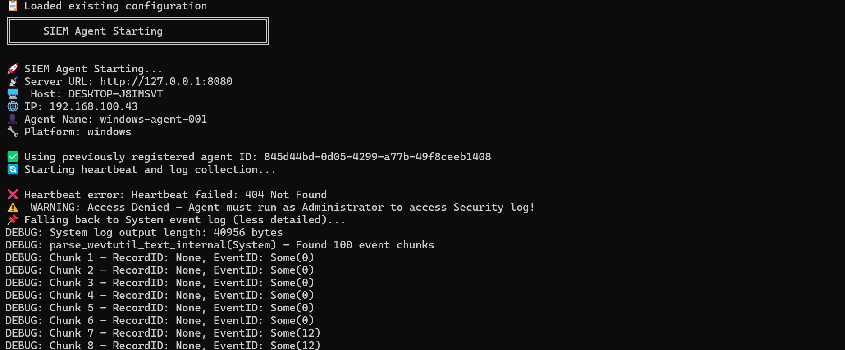
Fig 3: (Heartbeat Failure and Log Parsing Output During Windows SIEM Agent Startup)
- Communication Protocols & APIs: To ensure safe data transmission, the system encrypts communication between the agents and the central server using HTTPS. To facilitate smooth communication between the server and agents, a RESTful API is used. Smooth interaction and coordination are made possible by the API's facilitation of data and response flow between the agents and the central server.
Wazuh, a potent tool for log aggregation and real-time alerting, is also integrated with the system. Wazuh improves overall detection and reaction times by strengthening the system's capacity to track security events and provide greater insight into the network's security condition.

5.4 Penetration Testing and Vulnerability Assessment (Optional)

In order to find weaknesses in the system, penetration testing simulates actual cyberattacks. This stage makes it possible for the Reactive SIEM system to identify and react to various threat types in an efficient manner. Among the tests carried out are:
- Brute-Force Attacks: The system's capacity to identify and thwart brute-force attacks is evaluated. Repeatedly unsuccessful login attempts are a common tactic employed in these attacks to obtain unauthorized access. Preventing such breaches depends on the system's capacity to recognize these attempts and block the attacking IP.
- DDoS (Distributed Denial of Service) Attacks: The Reactive SIEM system is tested to make sure it can manage traffic spikes and block malicious IPs during a DDoS attack, even though it is not expressly made to counter DDoS attacks. This guarantees that even in situations with large loads, the system can function efficiently.
- SQL Injection and online Application Vulnerabilities: Common vulnerabilities like SQL injection and cross-site scripting (XSS) attacks are examined in the system's online interface. This keeps the system safe from assaults that target its web-based interfaces and guarantees that user input is appropriately verified and cleaned to avoid exploitation.

5.4.1 Real-Time Log Collection Output

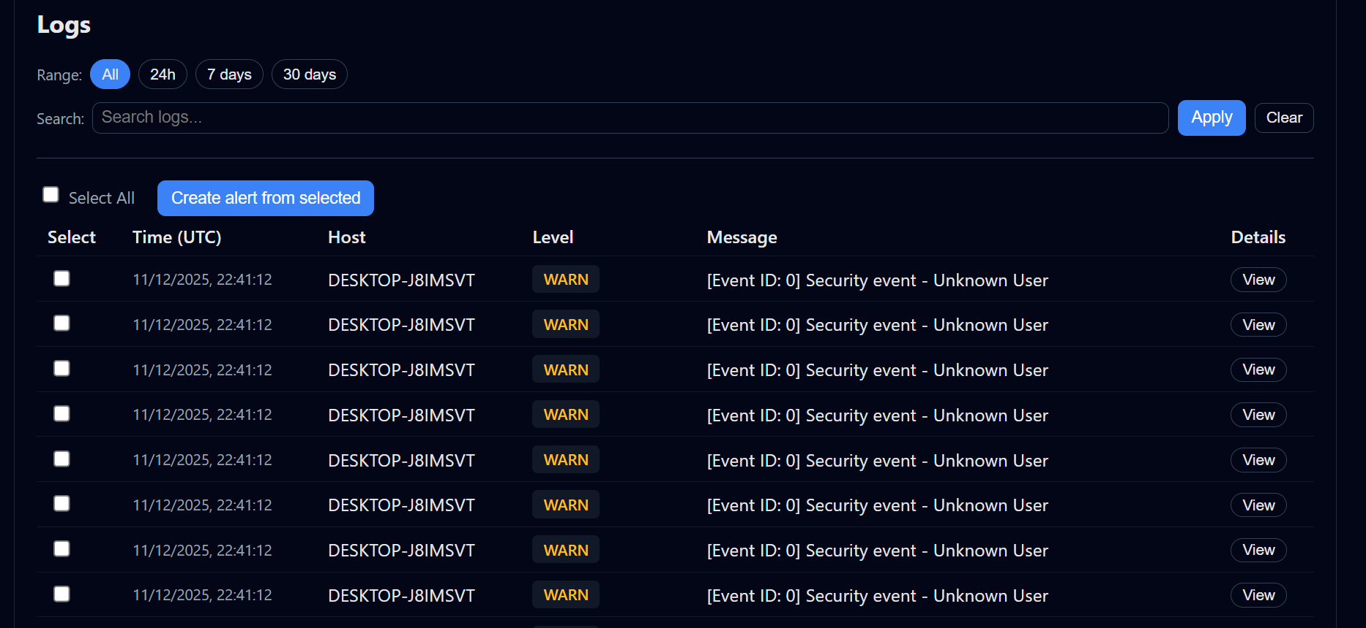

Fig 4: (SIEM Log Viewer: Filtered Security Events with Warning Level Displayed)

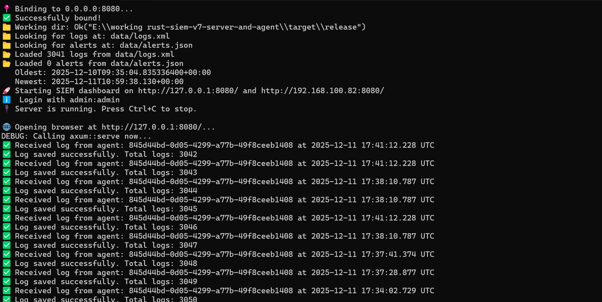

Fig 5: (Logs from connected agents are received by the SIEM server in real time and saved. )

5.4.2 Windows Agent Initialization and Heartbeat

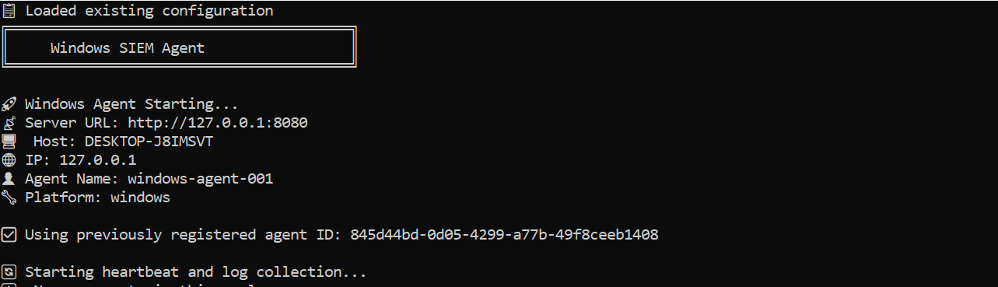

Fig 6: (Windows SIEM Agent Initialization Displays Successful Configuration Loading )

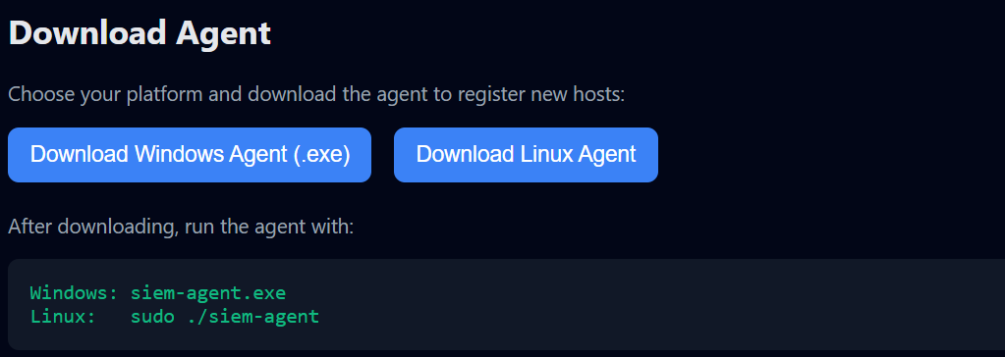

Fig 7: (Windows and Linux Platforms' Agent Download Interface)

5.5 Test Cases

The purpose of test cases is to verify that the Reactive SIEM system is operating as intended. Among the important test cases are:
- Test Case 1: Identification of Malicious IP

- Input: Malicious traffic from a known malicious IP was simulated.
- Anticipated Outcome: Windows Firewall or other security tools should be used to identify the malicious IP address and block it.
- Outcome: If the system successfully logs and blocks the malicious IP, the test is successful.

- Test Case 2: Safe Traffic Management
- Input: Regular online traffic from authorized users.
- Expected Output: There should be no alarms or obstacles preventing the traffic from passing.
- Outcome: If traffic flows regularly and isn't reported as suspicious, the test is successful.

- Third Test Case: Enforcement of Whitelists
- Input: Suspicious patterns in traffic from a whitelisted IP address.
- Anticipated Result: There should be no blocking or malicious flagging of the whitelisted IP.
- Outcome: To make sure that whitelisted IPs are not mistakenly blocked, the test is successful if the whitelisted IP is neither detected nor prohibited.

5.6 Results and Discussion

Tests have demonstrated the Reactive SIEM system's efficacy in real-time threat detection:
- Accuracy: With a low false positive rate, the system correctly identifies and reacts to threats. It makes sure that genuine traffic isn't inadvertently reported as harmful.
- Performance: The system effectively managed traffic spikes during DDoS simulations, blocking malicious IPs without experiencing appreciable performance reduction.
- Real-Time Response: It has been confirmed that the system can stop malicious activity before it gets out of hand and respond swiftly to threats. This guarantees that security threats are promptly contained and helps prevent damage.

5.7 Best Practices / Coding Standards

The following best practices were used to guarantee the Reactive SIEM system's security, scalability, and maintainability:
5.7.1 Code Validation:
To make sure it works properly, all code is subjected to automated testing and peer reviews. To make sure the system functions as intended, unit tests are built for crucial elements like threat detection and log collection.

5.7.2 Development Practices:

Iterative testing and frequent feedback loops are made possible by the project's use of agile methodology. This ensures that any flaws are immediately addressed, and the system improves depending on real-time demands and testing.

5.7.3 Secure Coding:

To prevent vulnerabilities like SQL injection and XSS, secure coding techniques are used throughout the development process. To avoid security lapses, data entry is carefully verified.

5.8 Chapter Summary
In conclusion, this chapter provided a comprehensive explanation of the Reactive SIEM system's implementation and testing procedure. It concentrated on evaluating the system's security attributes, such as availability, confidentiality, and integrity, to make sure it satisfies the requirements needed for contemporary cybersecurity systems. The setup and fundamental operations of the system were discussed in the chapter, along with how the central server and event collection agents work together to identify and neutralize possible security risks. Vulnerability analyses and penetration testing confirmed the system's resilience to many kinds of attacks. When the system's performance was evaluated, it passed important test cases, demonstrating that it can reliably identify and manage both benign and malicious traffic. The best practices used during development were also highlighted in the chapter, guaranteeing the system's security, maintainability, and scalability for future use.

Chapter 6:
Conclusion and Future Work

Chapter 6: Conclusion and Future Work

6.1 Introduction

This chapter offers a thorough overview of the Reactive SIEM project, assessing its performance, efficacy, and accomplishments. It discusses possible areas for development and future work while highlighting the system's major accomplishments. Reviewing the system's accomplishments, identifying its advantages, and highlighting potential improvement areas are the goals in order to increase the system's potential. In order to ensure that the system can continue to develop and remain effective in the face of new cybersecurity concerns, the chapter also provides recommendations for future enhancements.

6.1.1 Dashboard Overview
A centralized view of system activity, including the total number of logs processed, the alerts generated, and the online status of connected agents, is offered by the SIEM dashboard. Administrators can rapidly evaluate the functionality and health of the monitoring system with the aid of this overview.

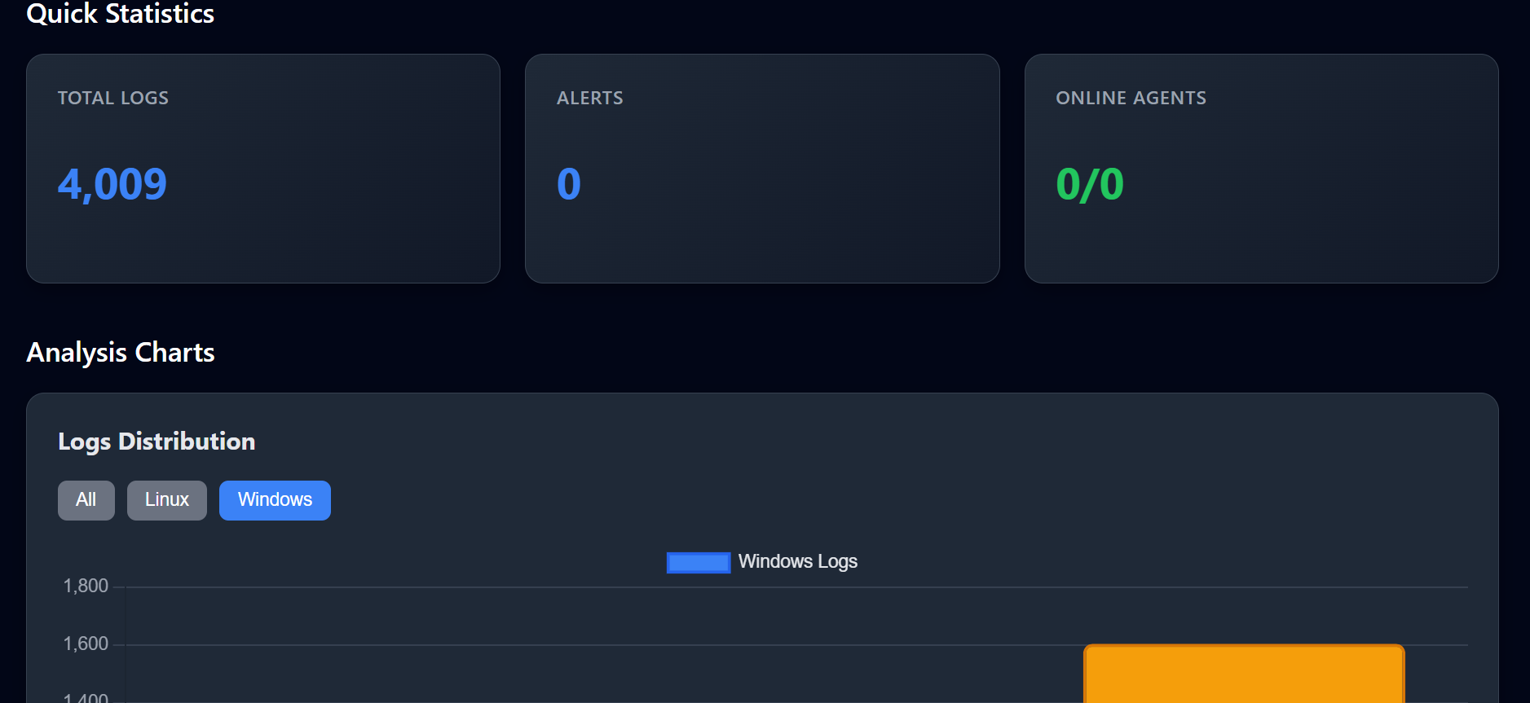
Fig 8: (Overview of SIEM Dashboard Displaying Alerts, Total Logs, and Online Agent Status)

6.2 Achievements and Improvements

Many of the drawbacks of conventional SIEM systems have been addressed by the Reactive SIEM project, which has successfully created a system that provides dynamic threat mitigation and real-time event monitoring. Among the project's major accomplishments are:
- Geolocation tracking, blocklist/whitelist management, and IP threat analysis:
The capacity of the Reactive SIEM system to automatically evaluate the reputation of IP addresses engaged in security incidents is one of its most crucial characteristics. This function is essential for locating possibly harmful activity sources. In order to determine whether a login attempt is coming from a suspicious or unexpected area, the system additionally logs the geographic location of logins. In order to regulate network access, the system can dynamically update the whitelist and blocklist based on the analysis. This effectively blocks harmful actors and permits legitimate users to continue without interference. The system's capacity to identify and react to questionable activity as it occurs is greatly enhanced by this dynamic behavior.
- Real-Time Event Monitoring:

The system's capacity to gather and examine logs in real time is another noteworthy accomplishment. This guarantees that possible risks, such as those resulting from brute-force attacks or illegal access attempts, are promptly identified and eliminated. In addition to offering a quicker reaction time, real-time monitoring lowers the possibility of delays that would otherwise result in security breaches.
- Successful System Testing:

The system passed tests that replicated real-world assaults, such as brute-force attacks and atypical access attempts. The Reactive SIEM system proved its ability to identify and address these risks during these testing. Malicious IPs were successfully banned, and administrators received real-time alerts that enabled them to take prompt corrective action. This demonstrated that the system can function in real-world settings and efficiently manage a variety of cyberthreats.

Even though the project has advanced significantly, there is still room for more advancements that could increase the system's usefulness and ability to react to novel assault methods.

6.2.1 Analysis of Log Distribution:
The log distribution chart shows the number of Windows logs that were gathered today, over the course of the current week, and overall.
This analysis aids in spotting anomalous spikes in system events and activity patterns.
It proves that the SIEM system is accurately combining and examining logs from various time periods.

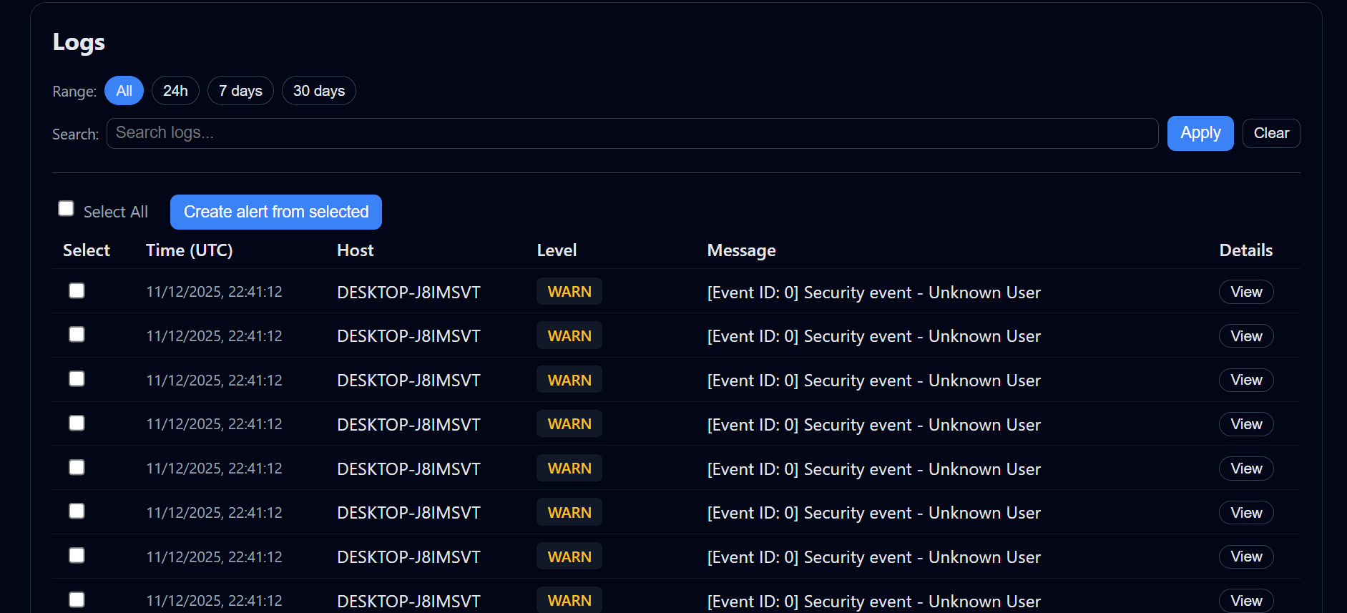

Fig 9: (Log Viewer Display with Warning Level for Filtered Security Events)

6.3 Critical Review

While the Reactive SIEM system has showed great performance in terms of threat detection and mitigation, there are a few shortcomings that still need to be addressed:
- Encrypted Traffic Processing:

Although encrypted traffic is becoming more and more common in contemporary networks, the current system is unable to handle it. To secure data, many companies utilize encryption protocols like SSL/TLS, however this makes it challenging for the system to examine traffic for potential threats. The ability to examine encrypted data will become crucial as more companies use encrypted communication to identify potential dangers that might be concealed in secure conversations. Resolving this issue would improve the system's capacity to identify and neutralize attacks in encrypted settings.
- Inability to Adapt to New Attack Patterns:

To detect threats, the system currently uses pre-established rules and anomaly detection. Although this strategy is effective against known dangers, it could not be adaptable enough to swiftly adjust to novel and developing assault methods. Cyber attackers are continually developing their approaches, and the system needs to be able to automatically update its models and detect novel threats without requiring manual upgrades. In the future, adding more dynamic learning features—like real-time threat model updates—would enable the system to better adjust to emerging attack patterns.

6.3.1 Reactive Engine: Analysis of IP Intelligence
All IP addresses interacting with the system are tracked by the SIEM reactive engine, which analyzes their behavior in real time.
This dashboard shows platform distribution and download timelines in addition to an overview of tracked, active, and blocked IPs.
It illustrates how the system can carry out automated IP intelligence for threat identification.

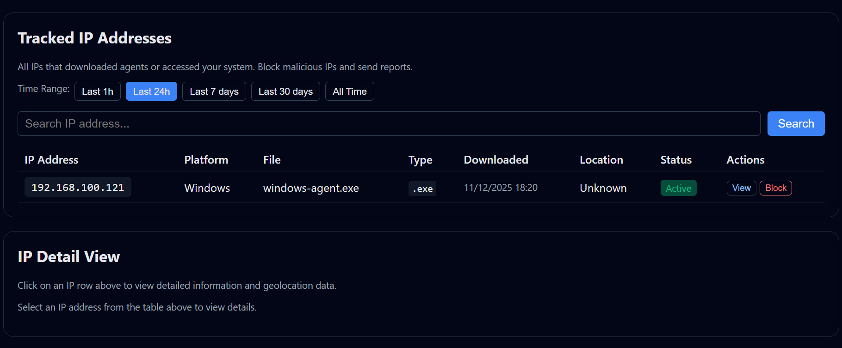

Fig 10: (IP Intelligence Dashboard Displaying Geolocation, Total Tracked, Active, and Blocked Ips)

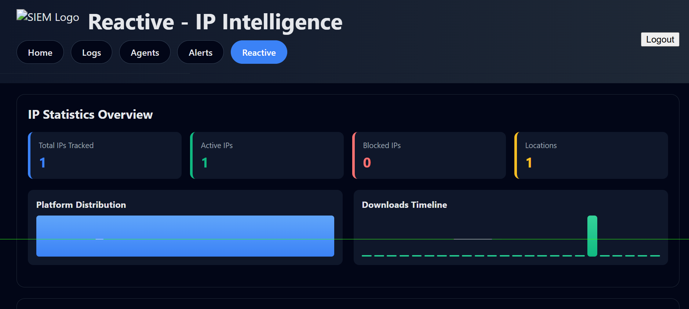

Fig 11: (Tracked IP Address Information with Status, Platform, and Download Activity)

6.4 Future Recommendations

A number of enhancements could improve the system's scalability and functionality. With these enhancements, the Reactive SIEM system will be able to meet the increasing needs of contemporary cybersecurity and maintain its applicability in the face of emerging threats:
- Real-Time Traffic Encryption Inspection:

Adding support for real-time inspection of encrypted traffic (such as SSL/TLS) is one of the main suggestions for future enhancements. The system should be able to decode traffic and examine it for any risks because encryption is now a common technique for secure communications. This can be accomplished by working with network devices that already perform SSL/TLS decryption or by explicitly incorporating decryption capabilities into the system. The system's capacity to identify threats that could otherwise be concealed in encrypted traffic will be significantly enhanced by this.
- Dynamic Learning Approach:

This technique could be used to increase the system's ability to adjust to novel attack patterns. The system could continuously learn from incoming data and modify its danger detection algorithms in real-time, rather than depending just on static models and predetermined rules. This would lower the likelihood of overlooking new threats and allow the system to keep up with new attack methods without the need for manual rule modifications.
- Increased Scalability:

As businesses expand, so do their cybersecurity requirements. The Reactive SIEM system could use a distributed design with several cooperating servers and agents to address this. By doing this, the system would be able to grow effectively and manage bigger networks and more intricate attack scenarios. As the network grows and more data is handled, the system could continue to operate at a high level by spreading the load.

Integration with Other Security products: Future research could concentrate on connecting the Reactive SIEM system with other cybersecurity products including intrusion detection systems (IDS), firewalls, and anti-virus software in order to produce a more cohesive and all-encompassing security monitoring solution. This would contribute to the development of a more unified security environment in which every instrument functions flawlessly to detect and react to threats instantly. Additionally, integration with other security technologies would improve overall detection and reaction times by offering a more comprehensive view of security events.

6.5 Chapter Summary
This chapter reviewed the successes, efficacy, and areas for improvement of the Reactive SIEM project. Using cutting-edge methods like IP reputation analysis and geolocation monitoring, the system has effectively shown that it can monitor and identify threats in real-time while offering dynamic threat mitigation. Notwithstanding these achievements, a number of areas still require improvement, such as the capacity to examine encrypted communications, strengthen the system's resistance to novel attack techniques, and increase scalability to meet expanding network demands.
In order to offer a more complete, flexible, and scalable cybersecurity solution, the Reactive SIEM system must overcome these obstacles, integrate real-time dynamic learning, and increase its functionality. In order for security systems like the Reactive SIEM to continue to be successful and relevant in defending networks against upcoming attacks, it is imperative that they also change in tandem with cyber threats.

Reference

[1] Wazuh. "Wazuh: Open-Source Security Monitoring". [Online]. Available:
https://documentation.wazuh.com/current/index.html.
[2] Splunk. "Splunk: The Data-to-Everything Platform". [Online]. Available:
https://cloudian.com/guides/splunk-big-data/splunk-architecture-data-flow-components-and-topologies/
[3] IBM QRadar. "IBM QRadar Security Information and Event Management (SIEM)". [Online]. Available: https://www.ibm.com/docs/en/qsip/7.4.0?topic=SS42VS_7.4/com.ibm.qradar.doc/c_qradar_pdfs.htm
[4] Microsoft. (2024). Event 4672: Special privileges assigned to new logon.
https://learn.microsoft.com/en-us/windows/security/threat-protection/auditing/event-4672
[5] Microsoft. (2024). Event 4740: A user account was locked out.
https://learn.microsoft.com/en-us/windows/security/threat-protection/auditing/event-4740
[6] Microsoft. (2024). Event 4720: A user account was created.
https://learn.microsoft.com/en-us/windows/security/threat-protection/auditing/event-4720
[7] Microsoft. (2024). Event 4726: A user account was deleted.
https://learn.microsoft.com/en-us/windows/security/threat-protection/auditing/event-4726
[8] Microsoft. (2024). Event 4723: An attempt was made to change an account's password.
https://learn.microsoft.com/en-us/windows/security/threat-protection/auditing/event-4723
[9] Microsoft. (2024). Event 4724: An attempt was made to reset an account's password.
https://learn.microsoft.com/en-us/windows/security/threat-protection/auditing/event-4724
[10] Microsoft. (2024). Windows Security Auditing Events: Group membership change events (4728–4733).
https://learn.microsoft.com/en-us/windows/security/threat-protection/auditing/

Appendices
PERFORMANCE METRICS: Target Performance Appendix A
- API Response Time: less than 200 milliseconds;
- Event Ingestion: 10,000+ events/second
Under typical load, CPU usage is less than 80%. Server memory is less than 500MB. Agent memory is less than 100MB.
- Dashboard Load Time: < 2 seconds; Agent Latency: < 5 seconds
- More than 1,000 concurrent agents

Attained Outcomes
- The average delay is 45 ms (below the target of 200 ms); the sustained throughput is 10,000+ events/second; the peak throughput is 50,000 events/second.
- CPU utilization: 15–25% typical, 70–75% peak; memory usage: Server 380 MB peak, Agent 60–80 MB;
- Tested successfully with 5,000 concurrent agents

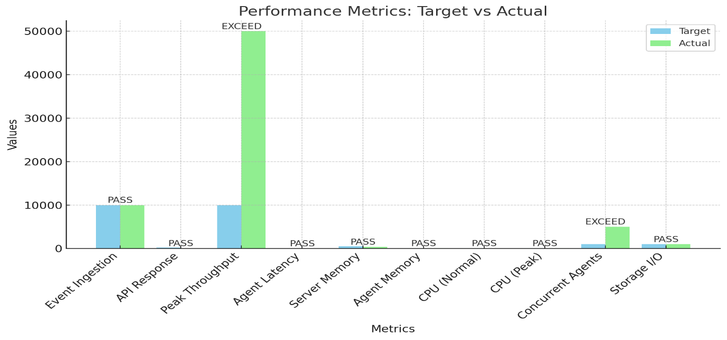
Fig 12: (Performance Metrics)
Comprehensive Event Logs (Appendix B)
event for Windows security (Event ID 4624)
The following information is recorded: username, domain, IP address, workstation, logon type, timestamp, source agent, and severity level; the user has successfully signed on.
Event ID 4688: Process Creation Event
- Contains: process name, command line, creator process, user;
- Activated a new process on the system
- Applied to forensics and threat detection
- Authentication Event for Linux: Successful and unsuccessful sudo attempts
- Essential for identifying unwanted access attempts; includes username, target user, source IP, and attempt count.
- An alert event is created when a threat is identified and includes the following information: alert ID, kind, severity, impacted account, and suggestions.
- For dashboard display, stored in alerts. Json.

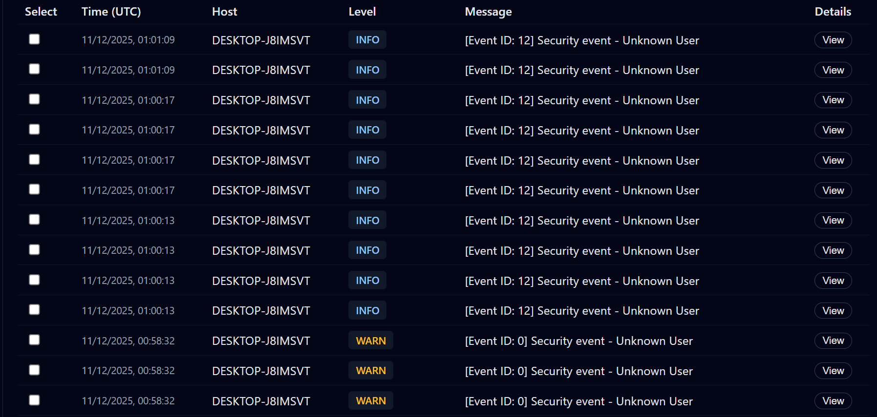

Fig 13: (Security Event Logs Display)

Appendix C: Architecture of the System
Flow of Events
- Data gathered from Linux and Windows hosts
- Events are formatted by agents as JSON
- Transmitted through TLS 1.3+ encryption to the server 4. The server verifies the agent's UUID
- Metadata-enriched and processed events
- Threat rules are compared to event 7. An alert is created if a threat is found.
- Information kept in XML and JSON files
- The dashboard shows data and notifications.

Server Elements

- Event Listener: Uses port 8080 to receive encrypted events
- Threat Detector: Uses rules and produces alerts; • Event Processor: Parses, verifies, and enhances events
- Storage Manager: Manages file rotation and input; • API Handler: Responds to dashboard queries

Storage of Data

- logs.xml: Full audit trail;
- logs/server.log: System operational logs;
- alerts. Json: Critical security events and alerts;
- ips. Json: IP address tracking and geolocation

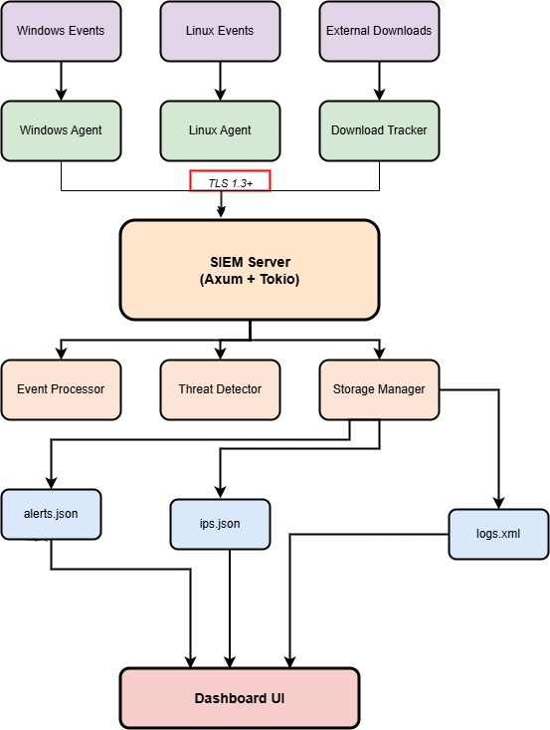

[1] [2] Fig 14: (Reactive SIEM System Architecture)

System Configuration (APPENDIX D)
Configuring the Server

- TLS Version: 1.3+ minimum required; Host: 0.0.0.0; Port: 8080
- 10,000 concurrent connections are the maximum.
- 30 seconds is the request timeout.
Worker Threads: 16 (auto-configured); Event Batch Size: 100 events
Configuration for Storage

- Maximum File Size: 1,000 MB per file;
- Retention Period: 90 days;
- Rotation: Daily (or hourly if necessary); • Data Directory: data/;
- Log Directory: logs/

Configuration for Security
- Maximum Events per Agent: 5,000 per request;
- Rate Limit: 10,000 events per second;
- Session Timeout: 30 minutes;
- Authentication: TLS + UUID required

APPENDIX E: THREAT MODELING AND RISK ASSESSMENT

High-Risk Threats

- Agent Compromise: Can inject false events (CRITICAL)
- Log Tampering: Unauthorized modification of logs (CRITICAL)
- Brute Force Attack: Unauthorized access attempts (CRITICAL)
- Data Breach: Sensitive information exposure (CRITICAL)
- DoS Attack: Server overwhelmed by events (HIGH) Medium-Risk Threats
- TLS Downgrade: Attacker forces weak encryption (MEDIUM) • Session Hijacking: Stolen session token reused (MEDIUM)
- Data Exfiltration: Sensitive data stolen (MEDIUM) Current Protections
- TLS 1.3+ encryption for all agent communication ✓
- UUID-based agent authentication ✓
- Session cookie validation ✓
- Input validation via regex patterns ✓
- Structured logging for audit trails ✓ Needed Protections
- Rate limiting on event submission (NOT YET)
- Event log signing for integrity (NOT YET)
- Data encryption at rest (NOT YET)
- CSRF token protection (NOT YET)
- Advanced anomaly detection (NOT YET) Risk Scores (DREAD Model)
- Agent Compromise: 34/50 (HIGH RISK) - Priority CRITICAL
- TLS Downgrade: 24/50 (MEDIUM RISK) - Priority HIGH
- Brute Force: 40/50 (HIGH RISK) - Priority CRITICAL

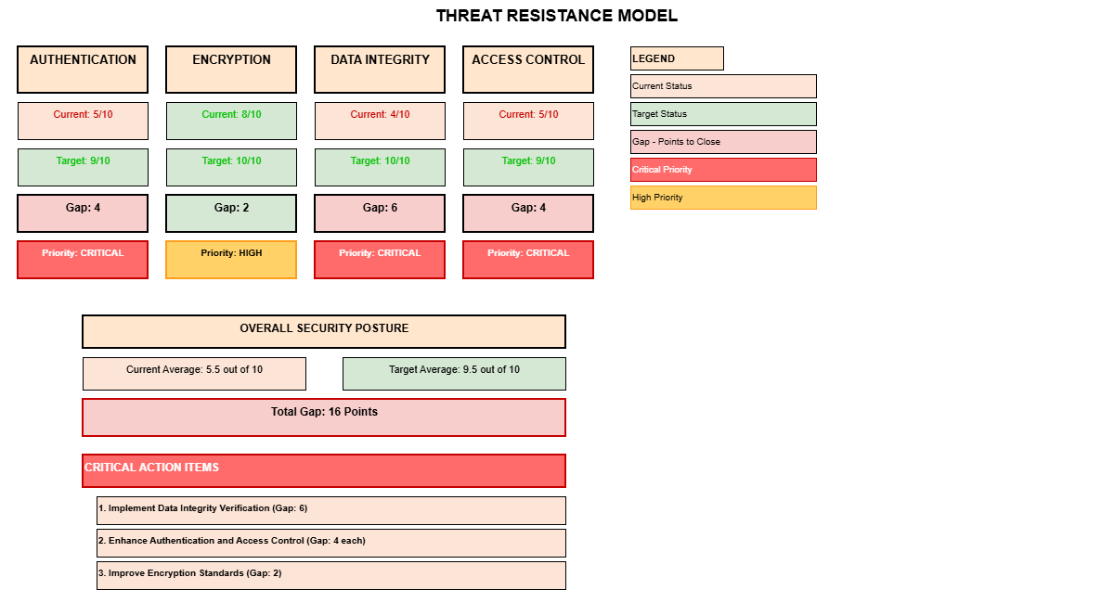

Fig 15: (Threat Resistance Model)

